**Customer Picking Order**

# ERD for UI/UX process

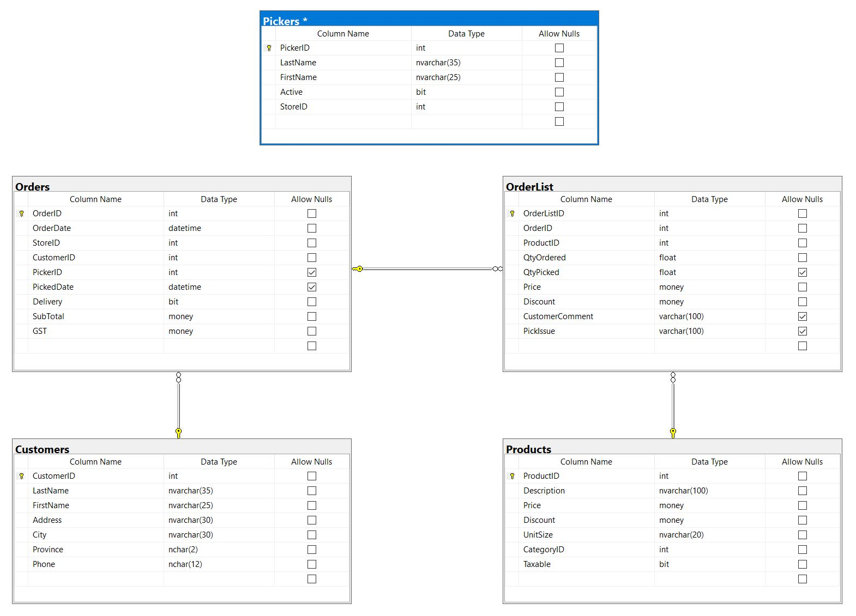

# Possible UX Interface

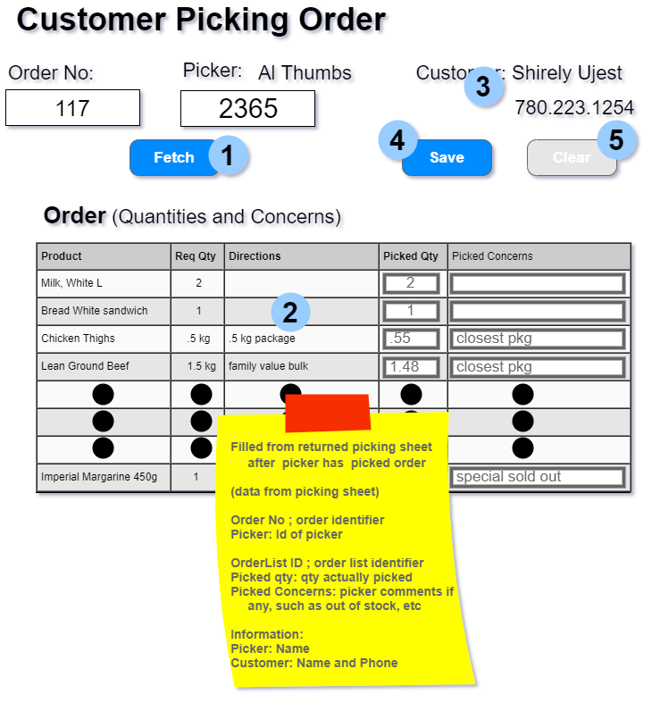

|  |  |
| --- | --- |
| **Controls** | **Events** |
| Fetch (**1**),  Customer(3) | OnClick   * Validate data OrderID was entered * Validate Presence * Call BLL |
| **BLL Class(es) and Method (s)** | |
| PickingOrderController | * List< CustomerItem> Customer_Find (int orderid, int customerid) * Retrieve customer info for supplied OrderID and hidden CustomerID. * Return * CustomerName * CustomerPhone |
| **SQL Table(s): (C,R,U,D)** | **ViewModels** |
| Orders(R), Customers(R) | CustomerItem |

|  |  |
| --- | --- |
| **Controls** | **Events** |
| Fetch (**1**) | OnClick   * Validate data PickerID was entered * Validate Presence * Call BLL |
| **BLL Class(es) and Method (s)** | |
| PickingOrderController | * List< PickerItem> Picker_Find (int pickerid) * Retrieve picker info for supplied PickerID. * Return * PickerName |
| **SQL Table(s): (C,R,U,D)** | **ViewModels** |
| Picker(R) | PickerItem |

|  |  |
| --- | --- |
| **Controls** | **Events** |
| Fetch (**1**),  OrderList(2) | OnClick / wired via ObjectDataSource   * Validate data OrderID was entered * Validate Presence * Call BLL * Bind returned data to PickingList |
| **BLL Class(es) and Method (s)** | |
| PickingOrderController | * List< OrderListItem> List_PickingOrderedItem (int orderid) * Retrieve a list of ordered items for supplied OrderID. * Return * ProductID * Description * QtyOrdered * CustomerComment * QtyPicked * PickerComment |
| **SQL Table(s): (C,R,U,D)** | **ViewModels** |
| OrderLists(R), Products(R) | OrderListItem, PickedItem |

|  |  |
| --- | --- |
| **Controls** | **Events** |
| Save (**4**),  OrderList(2) | OnClick   * Collect fields: QtyPicked and PickerComment * Validate data was entered * Send to BLL for updating * QtyPicked must be number * QtyPicked > 0 |
| **BLL Class(es) and Method (s)** | |
| PickerController | * void PickedItem_Update(OrderListItem orderlistitem) * Return rows affected |
| **SQL Table(s): (C,R,U,D)** | **ViewModels** |
| OrderLists(R, U) | OrderListItem, PickedItem |

|  |  |
| --- | --- |
| **Controls** | **Events** |
| Clear (**5**),  OrderNumber(1), PickerID(2),  OrderList(2) | OnClick   * Clear order number * Clear picker number * Clear info: picker and customer * Clear Order form |
| **BLL Class(es) and Method (s)** | |
|  |  |
| **SQL Table(s): (C,R,U,D)** | **ViewModels** |
|  |  |

|  |  |  |
| --- | --- | --- |
| **PickerItem** | | |
| OrderID | Int | Orders |
| PickerID | int | Orders |
| PickerName | int | Pickers |

|  |  |  |
| --- | --- | --- |
| **CustomerItem** | | |
| OrderID | int | Orders |
| CustomerID | int | Orders |
| CustomerName | int | Customers |
| CustomerPhone | string | Customers |

|  |  |  |
| --- | --- | --- |
| **OrderListItem** | | |
| OrderListID | int | OrderLists |
| ProductID | int | OrderLists |
| Description | string | Products |
| QtyOrdered | decimal | OrderLists |
| CustomerComment | string | OrderLiists |

|  |  |  |
| --- | --- | --- |
| **PickedItem** | | |
| QtyPicked | decimal |  |
| PickerComment | string |  |